Interaction Free Energy Analysis between SARS‑CoV‑2 Spike RBD Chains A and E

David Lázaro Alfranca, Zhipeng Pei & Jan Jardí Yanes
Biophysics 2025

Interaction Free Energy Analysis between SARS‑CoV‑2 Spike RBD Chains A and E 1
1. Introduction 3
2. Methodology 4
2.1. Protein Structure and Preparation 4
2.2 Interaction energies 5
2.2.1 Accessible Surface Area and Interaction Free Energy 5
2.2.2 Solvent Free Energy 5
2.2.2.1 Atom Type Assignment Methodology 6
2.2.3. Interface Definition 7
2.2.4 Van der Waals Free Energy 8
2.2.5 Electrostatic Free Energy 8
2.2.6 Overall Interaction Energy 9
2.3 Alanine mutations 9
2.4 Interface Visualisation with PyMOL 10
3. Results 10
3.1 Energetic Analysis of the Protein-Protein Interface 10
3.2. Interface Residues 11
3.3. ΔΔG Distribution 14
3.4. Structural Classification of Interface Interactions 15
3.5 RBD Variant Modeling and Energy Analysis (Alpha, Beta, and Delta) 17
3.5.1 Delta variant 17
3.5.2 Alpha variant 17
3.5.3 Beta variant 18
3.6 FoldX Strategy: Energetic Analysis of the Spike-ACE2 Interface 18
3.6.1 Structural Repair and Wild Type Baseline 18
3.6.2 Identification of Interface Hotspots (Alanine Scanning) 18
3.6.3 Energetic Impact of VOC Mutations 19
4. Discussion 20
5. Conclusions 21
6. References 21

1. Introduction
Knowing the energies involved in all protein–protein interactions is crucial to understanding how molecular complexes form, stabilize, and realize their biological function. In viruses such as SARS‑CoV‑2, infectivity, immune evasion, and the efficiency of viral entry into host cells depend on interactions of its spike protein with the host cell receptor or co-factors. In particular, the spike protein receptor binding domain (RBD) mediates the interactions with the other protein chains and the host receptors. Therefore, it has become the target of the majority of structural and energetic studies.
In humans, viral entry is initiated by the binding of the SARS-CoV-2 spike protein to the angiotensin-converting enzyme 2 (ACE2) receptor on the surface of host cells. This interaction, mediated by the spike protein receptor-binding domain (RBD), triggers conformational changes that facilitate membrane fusion and viral internalization. The strength and specificity of the spike–ACE2 interaction directly influence viral infectivity, transmissibility, and tissue tropism. Consequently, mutations that alter the energetic balance of this interface can enhance or weaken binding affinity, affecting disease severity and immune escape.
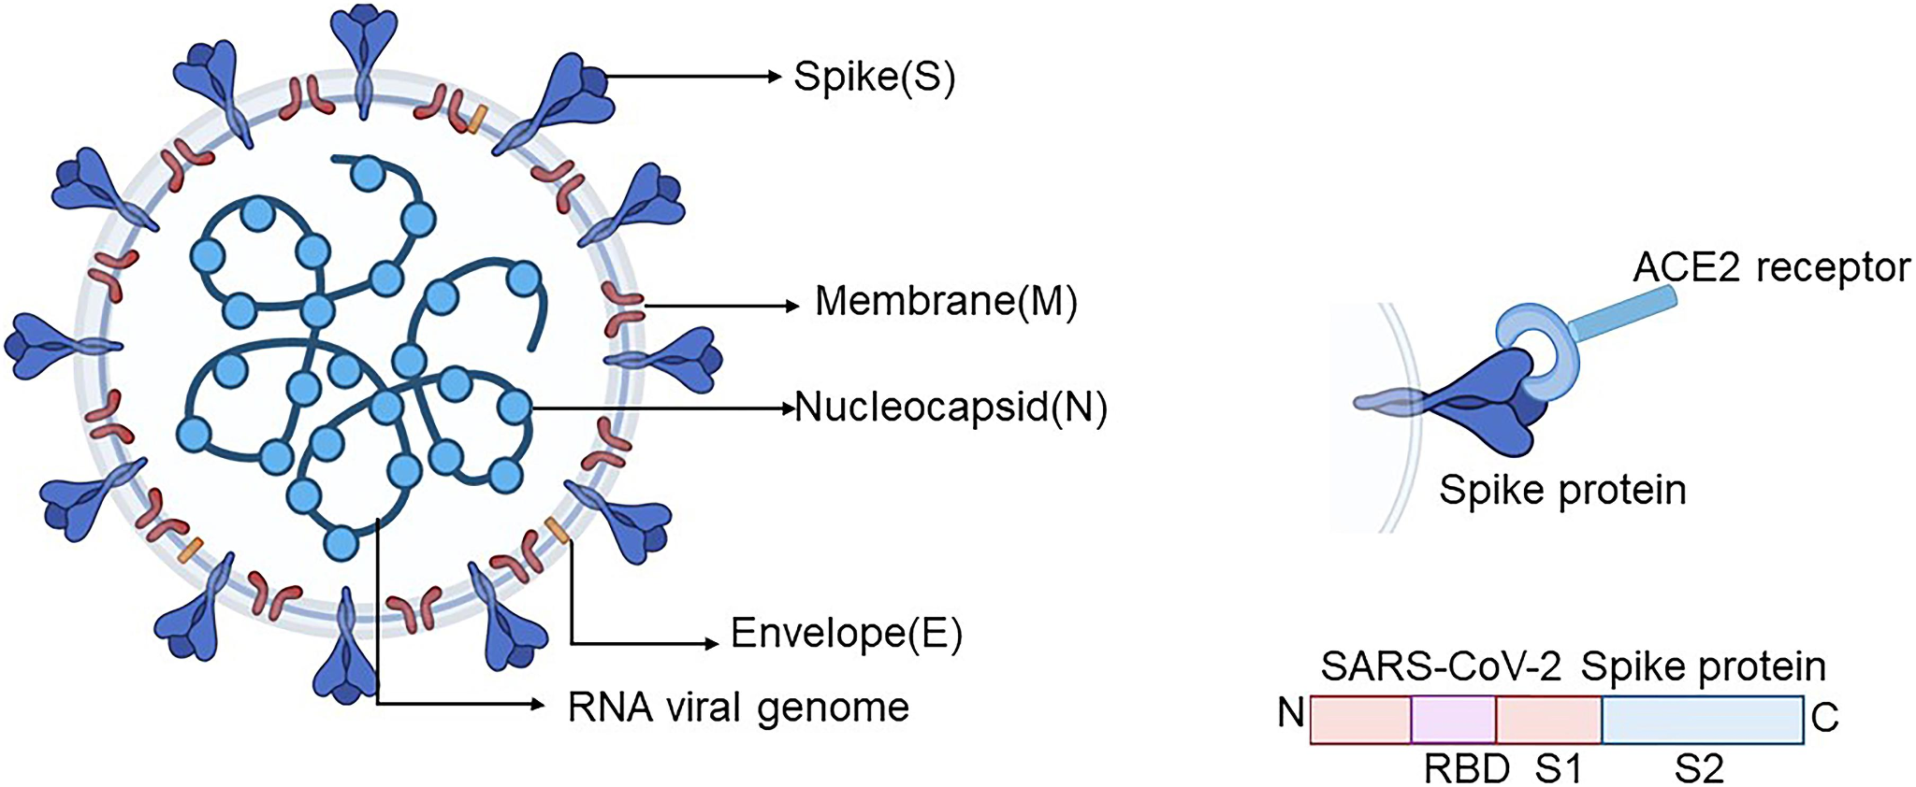
Figure 1: SARS-CoV-2 structure
Protein-protein interactions (or PPIs) are driven by multiple physicochemical forces, including van der Waals interactions, hydrogen bonding, electrostatics, and hydrophobic effects. Among them, the hydrophobic effect, which we quantified via changes in solvent-accessible surface area (ASA), plays a central role in stabilizing the interfaces between macromolecules (Chothia, 1974). In general, the buried surface area correlates with the strength of interaction; thus, the residues that become solvent-inaccessible upon complex formation make favorable contributions to binding free energy.
In this work, we quantify the interaction free energy between chains A and E of the SARS-CoV-2 spike protein (PDB: 6M0J) using an ASA-based approach. By identifying interface residues and estimating their energetic contributions, we aim to characterize the binding interface and highlight residues that are most relevant for complex stability, with implications for understanding mutation effects, drug targeting, vaccine design, and therapeutic antibody development.

2. Methodology

2.1. Protein Structure and Preparation
We retrieved the three-dimensional structure of the SARS-CoV-2 spike protein complex from the Protein Data Bank (PDB ID: 6M0J) and selected chains A and E, which form the interaction interface of interest. Structural preparation was performed using the biobb_structure_checking module. All non-protein components, including ligands, metal ions, and crystallographic water molecules, were removed. Hydrogen atoms were then added automatically, and partial atomic charges were assigned using the CMIP charge model. The final structure was generated in PDBQT format, which explicitly includes atomic charges, hydrogen atoms, and atom types, ensuring a chemically consistent representation suitable for solvent-accessible surface area calculations and ASA-based free energy estimation.
Here, we display the table of results summarising each model:
Num. models: 1  Num. chains: 2 (A: Protein, E: Protein)  Num. residues: 878  Num. residues with ins. codes: 0  Num. residues with H atoms: 0  Num. HETATM residues: 87  Num. ligands or modified residues: 7  Num. water mol.: 80  Num. atoms: 6558 | Final Num. models: 1  Final Num. chains: 2 (A: Protein, E: Protein)  Final Num. residues: 791  Final Num. residues with ins. codes: 0  Final Num. residues with H atoms: 791 (total 6116 H atoms)  Final Num. HETATM residues: 0  Final Num. ligands or modified residues: 0  Final Num. water mol.: 0  Final Num. atoms: 12522
Table 1: Comparison of Raw vs Cleaned model summary

The initial raw structure had one model with two protein chains, A and E, and included a total of 878 residues and 6,558 atoms. This raw model included 87 HETATM residues, of which 7 were ligands or modified residues and 80 were waters, while explicit hydrogen atoms on protein residues were absent.
After preprocessing, the final cleaned model contains one model with the same two protein chains A and E but is reduced to 791 residues due to removal of non-protein components and extraneous residues. All heteroatoms, ligands, and water molecules were removed in order to focus exclusively on protein–protein interactions. Explicit hydrogen atoms were added to all remaining residues, making the total count to 791 residues with 6,116 hydrogens and a total atom count of 12,522. This cleaning step is essential since it allows us to proceed with our study, making the calculations of the energies involved in protein-protein interactions possible.

2.2 Interaction energies

2.2.1 Accessible Surface Area and Interaction Free Energy
The solvent-accessible surface area (ASA), usually defined as a surface traced by a spherical probe rolling over a protein’s van der Waals surface, is used universally to estimate the nonpolar contribution to the interaction free energy (Lee & Richards, 1971). Programs such as NACCESS provide an efficient implementation of this algorithm, allowing per-atom ASA calculations which can then be mapped onto empirical surface tension coefficients derived from modified parameter sets (Hubbard & Thornton, 1993). By combining changes in ASA (ΔASA) with atom-specific coefficients, the solvation contribution to the interaction free energy can be estimated (Eisenberg & McLachlan, 1986).
ASA values were computed for the full complex (chains A and E together) and for each chain separately. The buried surface area for each atom was obtained as the difference between its ASA in the isolated chain and in the complex.
The difference for each atom represents the buried surface area, used to estimate free energy changes associated with desolvation and binding.
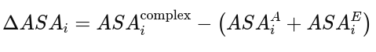

2.2.2 Solvent Free Energy
The solvation free energy contribution (ΔG_solv) was estimated from changes in solvent-accessible surface area (ΔASA) using a surface tension model, in which the energetic contribution of each atom is proportional to the area buried upon complex formation:

where ΔASAi is the buried solvent-accessible surface area of atom i (Å²), and σi is the surface tension coefficient associated with the chemical type of atom i (kcal·mol⁻¹·Å⁻²).
During this step, we encountered an issue related to atom naming. The .asa output file reported atoms using standard PDB atom names (e.g., CA, CB, CG1, HG12), while the surface tension parameters required for the calculation were defined for broader chemical atom types, such as aliphatic carbon, aromatic carbon, or polar hydrogen. To address this, we manually mapped each atom listed in the .asa file back to the original PDBQT PyMOL structure in order to identify its chemical nature based on residue type and bonding environment. This allowed us to correctly assign each atom to the appropriate chemical category and select the corresponding surface tension coefficient (σ).

2.2.2.1 Atom Type Assignment Methodology
The classification logic differentiates atoms not just by element, but by their chemical environment:
- Carbon: Atoms were classified as Aromatic (type 'A') if they belonged to the side-chain rings of Phenylalanine, Tyrosine, Tryptophan, or Histidine. All other carbons (aliphatic or backbone) were assigned type 'C'.
- Oxygen: A hierarchical classification was applied:
  - Carboxylate oxygens in Aspartic Acid (OD) and Glutamic Acid (OE) were assigned type 'OC'
  - Hydroxyl oxygens in Serine (OG), Threonine (OG1), and Tyrosine (OH) were assigned type 'OH'.
  - All remaining oxygens (primarily backbone carbonyls) were assigned type 'OA'.
- Hydrogen: Atoms were categorized by polarity: hydroxyl hydrogens as 'HO', polar hydrogens bonded to Nitrogen or Sulfur as 'HD', and non-polar hydrogens as 'H'.
- Other Elements: Nitrogens were assigned type 'N', Phosphorus as type 'P', and Sulfurs in Methionine or Cysteine as type 'SA'.
The resulting atom types were appended as a new column to the ASA input file.
This are the surface tension coefficients used:
Atom Type | σ (kcal/mol/Å²)
Aromatic C (A) | 0.111
Aliphatic C (C) | 0.019
N | –0.124
P | 0.000
SA | 0.026
HO | 0.000
HD | 0.000
H | 0.000
OH | -0.043
OC | –0.069
OA | –0.031
Table 2: Surface tension coefficient for each type of atom.

2.2.3. Interface Definition
The interface between protein chains can be defined using either physical criteria, such as residue proximity or distance-based cutoffs, or through energetic thresholds.
As an initial exploratory step, we identified residues from one chain whose atoms were located within 8 Å of residues in the opposing chain to obtain a preliminary view of the interface region. This distance cutoff was selected based on visual inspection of the complex in PyMOL, where 8 Å was found to optimally capture interfacial contacts while excluding residues not directly involved in the interaction. Nevertheless, the interface residues for chains A and E were ultimately defined using energetic thresholds based on ASA-derived free energy estimates. Specifically, residues exhibiting a non-negligible contribution to the ASA-based free energy, quantified as a solvent ΔG contribution greater than 0.1 kcal·mol⁻¹, were classified as interface residues. This threshold was chosen to exclude minor numerical fluctuations while retaining residues with a meaningful energetic impact on the interface. The residues surpassing this cutoff were considered binding hotspots, as their energetic contributions indicate a significant role in stabilizing the protein–protein complex. They are thought to be essential for complex stability and provide insight into mutation effects, drug targeting, vaccine design, and therapeutic antibody development.

2.2.4 Van der Waals Free Energy
The van der Waals free energy is the contribution of short-range, non-bonded interactions between atoms of ACE2 and the SARS-CoV-2 spike protein at their binding interface. These interactions rise from a balance between the attractive dispersion forces and repulsive steric effects and are highly sensitive to the exact spatial arrangement of atoms in contact. Favorable vdW interactions reflect a high degree of shape and surface complementarity, where side chains from both proteins pack tightly together without steric clashes. This close atomic packing favors the stability of the complex by maximizing dispersion forces, while poor geometric fits are penalized due to steric repulsion. As a consequence, vdW interactions are a physical measure of how efficiently the two chains fit together on the atomic level.
We assume that in this system, to compute the van der Waals energy, only interactions between atoms from different molecular chains can be considered, corresponding to the two binding partners. We discarded interactions between atoms within the same chain, since they do not contribute to the intermolecular interface. For each atom pair across the interface, we assign Lennard-Jones parameters (ϵ) (depth of the potential well) and (σ) (effective atomic radius) according to atom types, calculate the interatomic distance (r), and assess the interaction by means of the Lennard-Jones 12-6 potential:
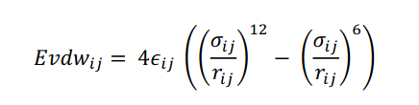
Here, the ($r⁻¹²$) term represents strong repulsion when atoms get too close, while the ($r⁻⁶$) term represents attractive dispersion forces at intermediate distances. We exclude atom pairs that are covalently bonded or beyond a cutoff (10 Å in our case), and we apply a switching function near the cutoff to avoid discontinuities. We obtain the total van der Waals energy by summing over all valid inter-chain atom pairs and it gives a measure of the degree of packing, complementarity, and structural fit at the protein-protein interface.

2.2.5 Electrostatic Free Energy
The electrostatic free energy accounts for long-range, non-bonded interactions between charged and polar atoms at the binding interface between ACE2 and the SARS-CoV-2 spike protein. These are due to attractive forces between oppositely charged groups, while like charges cause repulsion. These interactions are quite fundamental in molecular recognition and orientation, hence binding specificity. Favorable electrostatic interactions reflect complementary charge distributions across the interface, which stabilize this complex and guide the correct docking, while unfavorable charge arrangements penalize binding.
In the case of van der Waals interactions, only electrostatic interactions between atoms of distinct molecular chains are taken into account, since intrachain interactions do not contribute to binding. Each atom is assigned a partial charge (qᵢ) dependent on its atom type. For each inter-chain atom pair, the electrostatic interaction energy is computed based on Coulomb’s law including a distance-dependent dielectric constant:
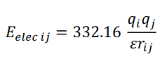
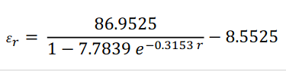
In this expression, (qi) and (qj) represent the partial charges on atoms (i) and (j), (rij) is the distance between them in Ångströms, and (𝜀) is the effective dielectric constant that accounts for the screening effects of the solvent and the protein environment. The constant 332.16 is a unit conversion factor that ensures the resulting energy is expressed in kcal/mol.
The summation over all inter-chain atom pairs gives the total electrostatic free energy. This term represents the contribution of charge complementarity, salt bridges, and long-range electrostatic steering to the stability and specificity of the ACE2–spike protein complex.

2.2.6 Overall Interaction Energy
Finally, we just have to sum all the energies we previously computed. This is the formula:

2.3 Alanine mutations
In this step, we perform an in silico alanine scanning of the protein–protein interface to evaluate the contribution of each interface residue to the binding free energy ΔG_A–B. We first calculate the wild-type binding free energy as the sum of electrostatic interactions, van der Waals interactions, and a solvation term based on solvent-accessible surface area. Then, for each interface residue, we simulate a mutation to alanine by removing all side-chain atoms beyond CB while keeping the backbone unchanged, taking advantage of the fact that alanine’s side chain is common to all amino acids except glycine. In this step, we recompute the binding free energy for each mutated complex and calculate ΔΔG = ΔG_Ala − ΔG_WT. Finally, we compare and plot the ΔΔG values to identify residues whose mutation causes the largest destabilization of the interface, allowing us to relate their energetic importance to the chemical nature of the original amino acids (hydrophobic, charged, or polar).

2.4 Interface Visualisation with PyMOL
We used PyMOL for molecular modeling and rendering to visualize the spatial arrangement and structural environment of these selected residues. We first extracted the mutation sites and defined their immediate environment within a 5 Å radius from them. To ensure clarity in visualization, we depicted the global structure as a transparent cartoon, with the target residues highlighted in red sticks and the environment in grey, with labels on alpha carbons for precise identification. To generate the animation, we implemented an automated rotation script in PyMOL that captured 36 high-resolution, ray-traced frames across a full 360-degree rotation. Finally, we compiled and processed the work on Canva to get a smooth, looping GIF that delineates the protein structural context dynamically.

3. Results

3.1 Energetic Analysis of the Protein-Protein Interface
We assessed the binding affinity between the two chains (Chain A and Chain E) by analyzing the solvent, electrostatic, and van der Waals energy contributions, which represent the main enthalpic driving forces for complex formation.
We obtained a strong attractive electrostatic energy ΔG_elec of -17.79 kcal/mol. This large negative value implies high electrostatic complementarity at the interface, pointing to important salt bridges or hydrogen bond networks responsible for the stability of the interaction.
The van der Waals contribution ΔG_vdw was calculated as -36.9741 kcal/mol. Summation of these terms emphasizes that shape complementarity and specific polar interactions, a combination of vdW and electrostatics, drive complex stability.
The solvation energy, ΔG_solv, was +10.6892 kcal/mol, suggesting an unfavorable desolvation penalty upon complex formation in tune with the burial of polar and charged surface area.
The total interaction free energy is overall ΔG_total = -44.07 kcal/mol, indicating complex stability is dominated by favorable van der Waals interactions, reinforced by electrostatics, and partially opposed by solvation effects.

3.2. Interface Residues
As stated before, after applying this 0.1 kcal/mol we obtained this list of interface residues:
Residue | ΔASA (Å²) | ΔG_solv (kcal/mol)
A 19 SER | -10.364 | 1.034656
A 24 GLN | -53,76 | 1.195422
A 28 PHE | -16.287 | 0.108872
A 30 ASP | -41.643 | 1.843473
A 31 LYS | -91.626 | 3.216684
A 34 HIE | -79.636 | 2.152237
A 35 GLU | -19.781 | 1.151886
A 37 GLU | -13.585 | 0.432561
A 38 ASP | -34.647 | 1.734384
A 41 TYR | -42.762 | 0.865332
A 42 GLN | -46.503 | 4.895923
A 82 MET | -26.727 | 0.139283
A 83 TYR | -36.48 | 1.093275
A 325 GLN | -8.134 | 0.130200
A 330 ASN | -29.069 | 2.498073
A 353 LYS | -97.158 | 3.361113
A 354 GLY | -29.723 | 0.958613
A 357 ARG | -12.647 | 1.537724
A 393 ARG | -11.023 | 1.366852
E 403 ARG | -1.556 | 0.192944
E 417 LYS | -28.71 | 1.283028
E 446 GLY | -16.75 | 0.538842
E 449 TYR | -35.122 | 1.060466
E 453 TYR | -18.26 | 0.695181
E 475 ALA | -39.159 | 0.712535
E 477 SER | -1.234 | 0.153016
E 484 GLU | -13.238 | 0.913422
E 486 PHE | -99.975 | 0.188604
E 487 ASN | -36.763 | 2.918991
E 489 TYR | -71.301 | 1.097145
E 493 GLN | -89.896 | 9.097539
E 496 GLY | -20.898 | 0.950367
E 498 GLN | -55.843 | 4.103625
E 500 THR | -92.014 | 1.517835
E 501 ASN | -30.772 | 0.936386
E 502 GLY | -35.191 | 1.499284
E 505 TYR | -87.372 | 1.104799
Table 3: Surface Area (ΔASA) and Solvation Free Energy (ΔG_solv) for Selected Interface Residues.

3.3. ΔΔG Distribution
Following the identification of interface residues, Alanine Scanning Mutagenesis was performed to assess the energetic contribution of individual amino acids for the complex stability. The change in binding free energy (ΔΔGbinding) was calculated as the difference between the mutant and wild-type energies:
ΔΔGbinding = ΔGmutant - ΔGwild-type
A positive ΔΔG value indicates that the mutation is destabilizing, suggesting the original residue is critical for the interaction (a 'hotspot'). Conversely, a negative value indicates that the mutation stabilizes the complex. The following residues are considered the most determinant in complex stability:
E-486-PHE ΔΔG = 14.236 kcal/mol
E-505-TYR ΔΔG = 12.394 kcal/mol
E-489-TYR ΔΔG = 9.376 kcal/mol
A-41-TYR ΔΔG = 4.718 kcal/mol
A-37-GLU ΔΔG = 3.274 kcal/mol
A-34-HIE ΔΔG = 2.668 kcal/mol
E-501-ASN ΔΔG = 2.256 kcal/mol
A-83-TYR ΔΔG = 2.149 kcal/mol
E-403-ARG ΔΔG = 1.923 kcal/mol
E-500-THR ΔΔG = 1.705 kcal/mol
A-35-GLU ΔΔG = 1.617 kcal/mol
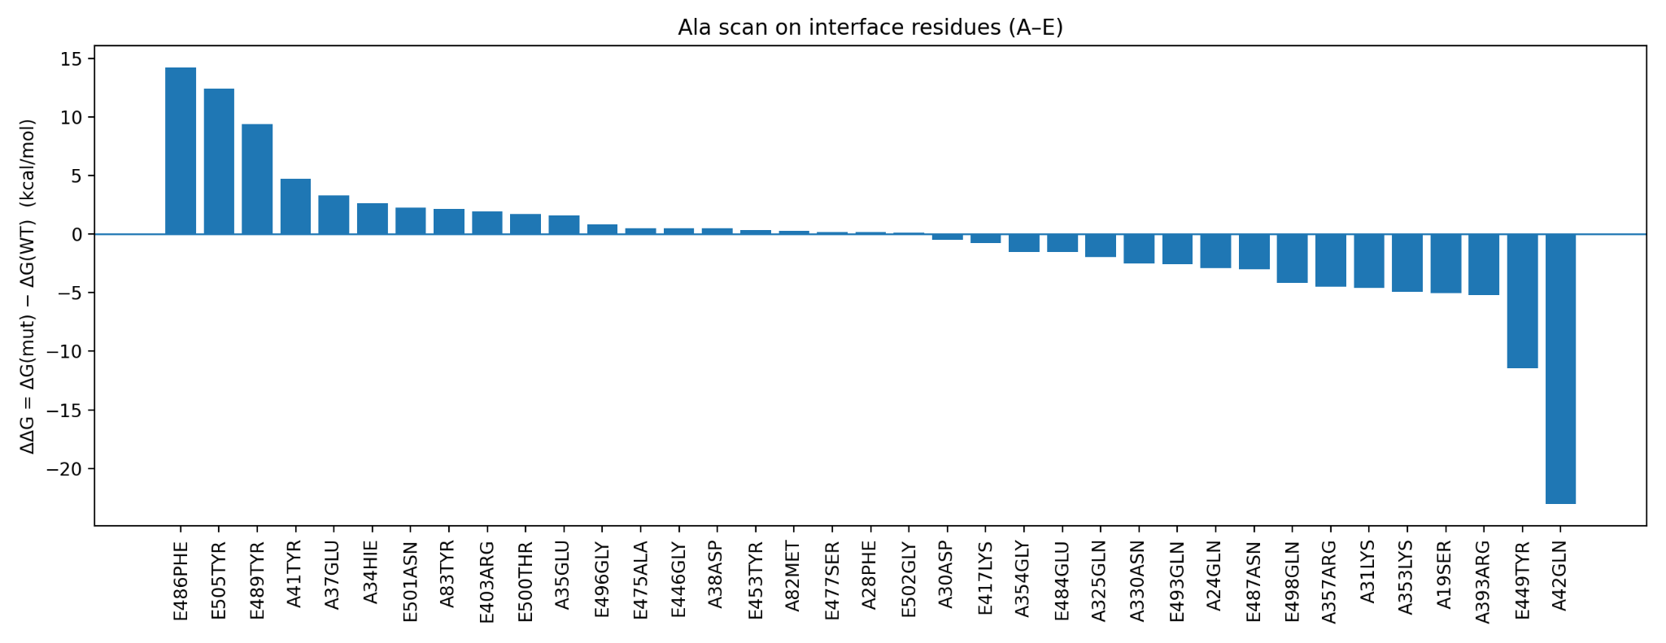
Figure 2: Barplot of most relevant residues for stability in the interface.

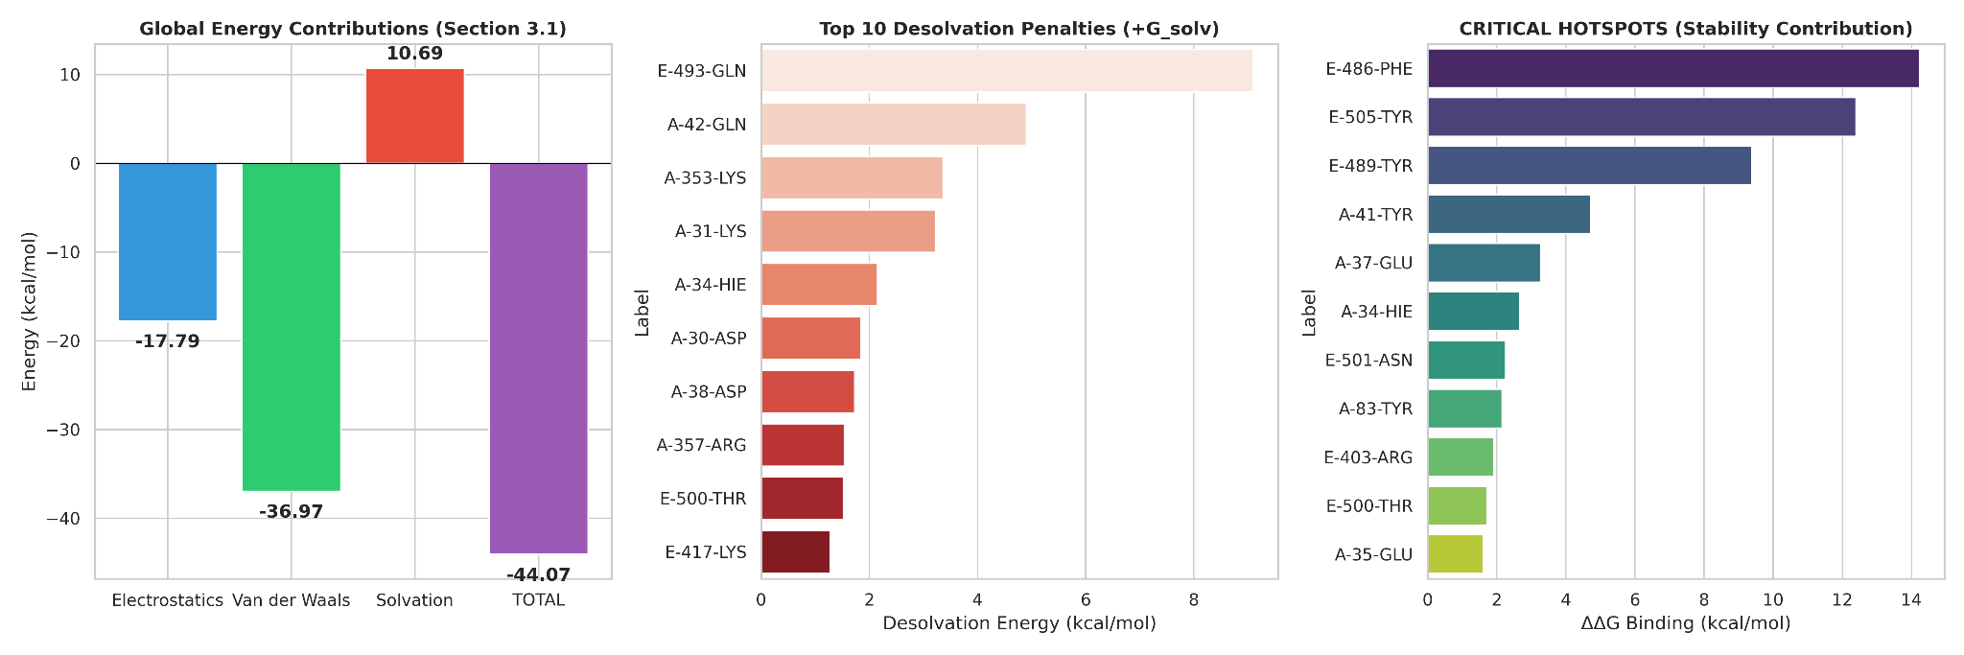
Figure 3: Energetic dissection of the SARS-CoV-2 Spike (RBD) – ACE2 interface. (A) Global energy contributions to binding. The stability of the complex ΔGtotal=−44.07 kcal/mol is mostly driven by Van der Waals forces (−36.97 kcal/mol) and Electrostatics (−17.79 kcal/mol), which overcome the unfavorable desolvation penalty (+10.69 kcal/mol). (B) Top 10 Desolvation Penalties. Polar and charged residues such as E-493-GLN and A-42-GLN have the highest energetic cost to be buried at the interface. (C) Critical Interface Hotspots. Residues with the highest contribution to binding stability ΔΔG. Hydrophobic residues, such as E-486-PHE and E-505-TYR, are the main structural anchors.

3.4. Structural Classification of Interface Interactions
To support our energetic analysis with structural evidence, we identified the key atomic contacts responsible for stabilizing the complex. Using a distance-based structural scanning algorithm on the PDB 6M0J structure, we mapped the strongest non-covalent interactions (distance ≤ 3.0 Å) between the ACE2 receptor (Chain A) and the SARS-CoV-2 Spike RBD (Chain E).

Rank | ACE2 Residue (Chain A) | Spike RBD Residue (Chain E) | Interaction Type | Distance (A˚) | Structural Significance
1 | GLN 24 | ASN 487 | Hydrogen Bond | 2.56 | High Specificity Anchor
2 | TYR 41 | THR 500 | Hydrogen Bond | 2.58 | Hotspot Stabilization
3 | LYS 353 | GLY 502 | Hydrogen Bond | 2.78 | Backbone Interaction
4 | HIS 34 | TYR 453 | Hydrogen Bond | 2.80 | Polar Network
5 | ASP 38 | TYR 449 | Hydrogen Bond | 2.83 | Polar Network
6 | TYR 83 | ASN 487 | Hydrogen Bond | 2.84 | Aromatic Stacking / H-Bond
7 | ASP 30 | LYS 417 | Salt Bridge | 2.90 | Critical Electrostatic Lock
8 | LYS 353 | GLY 496 | Hydrogen Bond | 2.91 | Backbone Interaction
9 | GLN 42 | TYR 449 | Hydrogen Bond | 2.95 | Side-chain Contact
10 | GLN 42 | GLY 446 | Hydrogen Bond | 3.02 | Side-chain Contact
Table 4. Top 10 Strongest Atomic Interactions at the Spike-ACE2 Interface. Residues are sorted by bond distance. Shorter distances indicate stronger, more stable interactions.
The structural analysis reveals a dense network of hydrogen bonds that contribute to the binding specificity between ACE2 and the Spike RBD. Notably, the data confirm the presence of a strong salt bridge (2.90 Å) between Asp30 of ACE2 and Lys417 of the Spike protein. This ionic interaction plays a key role in stabilizing the complex through electrostatic forces. In the K417N variant, however, the substitution results in the loss of this positive charge, effectively disrupting the salt bridge. This structural disruption, as predicted by FoldX analysis, accounts for the marked decrease in binding affinity.

3.5 RBD Variant Modeling and Energy Analysis (Alpha, Beta, and Delta)
The results obtained from the other RBD variants are as follows:

3.5.1 Delta variant
The Delta RBD variant ended up being the most favorable total interaction energy (-36.90 kcal·mol⁻¹), indicating the strongest binding among the variants analyzed. The interaction is dominated by van der Waals forces (-34.0 kcal·mol⁻¹), with a smaller but favorable electrostatic contribution (-4.0 kcal·mol⁻¹). The polar solvation term is slightly unfavorable (+1.05 kcal·mol⁻¹) and does not significantly weaken the overall stability, pointing to enhanced binding driven mainly by improved structural packing.

3.5.2 Alpha variant
For the Alpha RBD variant, we obtain a favorable total interaction energy of approximately −31.21 kcal·mol⁻¹, indicating stable binding, though weaker than Delta. Binding is primarily driven by van der Waals interactions (−31.76 kcal·mol⁻¹) and supported by favorable polar solvation (−9.45 kcal·mol⁻¹). However, this stabilization is partially counteracted by an unfavorable electrostatic contribution (+10.0 kcal·mol⁻¹), suggesting that hydrophobic packing dominates Alpha binding while electrostatics reduce the net affinity.

3.5.3 Beta variant
For the Beta RBD variant, we compute the least favorable total interaction energy (−24.82 kcal·mol⁻¹) among the three variants. Stabilization arises from electrostatic (−10.43 kcal·mol⁻¹) and van der Waals (−5.68 kcal·mol⁻¹) interactions, together with a favorable polar solvation term (−8.71 kcal·mol⁻¹). Despite these contributions, the overall binding strength remains weaker compared with Delta and Alpha.

3.6 FoldX Strategy: Energetic Analysis of the Spike-ACE2 Interface
To quantify the thermodynamic stability of the SARS-CoV-2 RBD/ACE2 complex and evaluate the impact of specific mutations, we employed the FoldX force field. This structure-based algorithm calculates the Gibbs Free Energy ($ΔG$) of the protein complex, allowing for the prediction of binding affinity changes upon mutation.

3.6.1 Structural Repair and Wild Type Baseline
Prior to energetic analysis, the crystal structure (PDB: 6M0J) underwent an energy minimization process using the “RepairPDB” command. This step corrected high-energy Van der Waals clashes and optimized side-chain rotamers to reach a thermodynamic local minimum.
The interaction energy ($ΔG_{binding}$) for the repaired Wild Type (WT) complex was calculated as -17.18 kcal/mol. This highly negative value indicates a stable protein-protein interface driven by a dense network of hydrogen bonds and hydrophobic contacts. This value serves as the baseline reference ($ΔΔG = 0$) for all subsequent mutational analyses.

3.6.2 Identification of Interface Hotspots (Alanine Scanning)
To map the residues most critical for binding, we performed a computational Alanine Scanning (“BuildModel”). All interface residues were individually mutated to Alanine, and the change in binding energy ($ΔΔG$) was calculated. A positive $ΔΔG$ indicates that the original residue contributes to stability (destabilization upon mutation).
The analysis revealed several "hotspots" (residues with $ΔΔG$ > 2.5 kcal/mol), confirming that the interface stability relies heavily on specific aromatic and electrostatic interactions.
Rank | Chain | Residue | Mutation | ΔΔG (kcal/mol) | Role
1 | A (ACE2) | Tyr 41 | Y41A | +5.60 | Critical Anchor
2 | A (ACE2) | Tyr 83 | Y83A | +4.66 | Stacking Interaction
3 | A (ACE2) | Arg 357 | R357A | +4.43 | Electrostatic
4 | E (Spike) | Arg 403 | R403A | +4.35 | Salt Bridge Potential
5 | E (Spike) | Tyr 505 | Y505A | +3.95 | RBD Contact

Table 5. Critical Interface Hotspots identified by FoldX
The dominance of Tyrosine (Tyr) and Arginine (Arg) residues in the top-ranking hits highlights the importance of shape complementarity and hydrogen bonding interactions at the viral entry point.

3.6.3 Energetic Impact of VOC Mutations
Finally, we modeled three specific mutations associated with Variants of Concern (VOCs) to predict their effect on ACE2 binding affinity.
Variant | Mutation | Binding Energy (ΔG) | ΔΔG (Mut−WT) | Predicted Effect
Wild Type | - | -17.18 kcal/mol | 0.00 | Reference
Alpha | N501Y | -16.99 kcal/mol | +0.19 | Neutral / Minor Destabilization
Beta/Gamma | E484K | -17.52 kcal/mol | -0.34 | Stabilizing (Higher Affinity)
Beta/Gamma | K417N | -15.11 kcal/mol | +2.07 | Destabilizing (Loss of Affinity)

Table 6. Predicted Affinity Changes for Analyzed Variants

4. Discussion
Our approach combines structural analysis with energy breakdowns to better understand what keeps the ACE2–SARS-CoV-2 spike RBD complex stable. By using tools like solvent-accessible surface area (via NACCESS), empirical solvation parameters, and specific energy terms for van der Waals and electrostatic forces, we break down the interaction energy in a way that makes physical sense. Simply put, we connect structural features of the interface directly to their energetic impact.
The total interaction energy is highly favorable, around −44.07 kcal/mol, which implies that the complex is very stable. This stability comes from a balance: attractive forces like van der Waals and electrostatics pull the proteins together, while solvation penalties push back. The solvation term is actually a cost of +10.69 kcal/mol. It reflects the energy needed to remove water when polar or charged areas get buried during binding, which is a common challenge in protein–protein interactions.
Van der Waals interactions contribute the most, around −37 kcal/mol. That highlights how important tight packing and shape complementarity are. This energy mainly comes from hydrophobic and aromatic residues on the RBD slipping into matching pockets on ACE2. The more buried surface area, the stronger the van der Waals effect. That makes hydrophobic collapse a major driver of binding.
Electrostatic interactions also play a meaningful role, contributing about −17.8 kcal/mol. While not as strong as van der Waals forces, they help compensate for the desolvation of charged groups. This suggests that the interface includes organized salt bridges and hydrogen bond networks. These electrostatic interactions also help guide the proteins into the right orientation before they fully bind, which is crucial for specificity.
One thing that really stands out is the role of tyrosine residues at the ACE2–RBD interface. Alanine scanning and FoldX both identify residues like Tyr41 and Tyr83 on ACE2, and Tyr449, Tyr489, and Tyr505 on the RBD, as major energetic hotspots. Tyrosine is unique because its aromatic ring helps with hydrophobic packing and π–π stacking, while the hydroxyl group forms hydrogen bonds. This dual role makes it especially good at stabilizing protein–protein contacts.
Alanine scanning backs this up by showing that mutating aromatic and charged residues leads to significant destabilization, with ΔΔG values greater than 2 kcal/mol. Key residues like Phe486, Tyr505, and Tyr489 on the RBD, and Tyr41 and Tyr83 on ACE2, have particularly strong effects. Charged residues such as Arg403 and Glu37 also play a big part, showing how electrostatic complementarity adds to hydrophobic interactions.
FoldX was used here not as the primary method, but as an independent check to validate our main analysis. The fact that FoldX pinpointed the same energetic hotspots as alanine scanning and energy decomposition shows that our method is capturing the right details. This kind of cross-validation helps confirm that our results are indeed correct.
When we look across variants like Alpha, Beta, and Delta, we see different energetic profiles. Delta has the most favorable binding energy, mostly due to stronger van der Waals forces. That suggests better packing and surface fit. Alpha and Beta bind more weakly, each with their own mix of electrostatic and solvation effects. These energy shifts match up with how easily each variant spreads, showing how small sequence changes can reshape the interaction energy.
Overall, the agreement between ASA-based energy breakdowns, alanine scanning, and FoldX validation shows that this computational method does a good job identifying the key physical factors behind ACE2–RBD binding. Even though it doesn’t include entropy or detailed dynamics, it still provides useful insight into which residues matter, how mutations affect binding, and what that means for viral evolution, immune escape, and drug design.

5. Conclusions
In conclusion, we successfully quantified the energetic contributions of individual interface residues mediating the interaction between chains A and E of the SARS-CoV-2 spike RBD. We combined structural preparation with calculations of changes in solvent-accessible surface area and explicit van der Waals and electrostatic energy terms to achieve a quantitative description of the main forces that stabilize the protein–protein interface.
The alanine scanning analysis identified a number of crucial hotspots-very aromatic and charged amino acids-whose mutation was associated with strong complex destabilization. These results emphasize the prevalent role of van der Waals interactions in interface stability, supplemented by specific electrostatic contacts that confer binding specificity.
Consequently, comparison across Alpha, Beta, and Delta RBD variants revealed variant-dependent differences in binding energetics, with Delta showing the strongest interaction. And our study shows how ASA-based energy decomposition and in silico mutagenesis can effectively distinguish critical residues; therefore, providing important insight into vaccine design, therapeutic targeting, and analyses of emerging viral variants.

6. References
- Lee & Richards, 1971 — The interpretation of protein structures: estimation of static accessibility
- Hubbard & Thornton, 1993 — NACCESS
- Eisenberg & McLachlan, 1986 — Solvation energy in protein folding and binding
- Chothia, 1974 — Hydrophobic bonding and accessible surface area in proteins
- Janin, 1999 — Protein–protein recognition at crystal contacts

